SALE OF NONAPPROPRIATED FUND PROPERTY

56 FSS/MWR SERVICES is Accepting Sealed Bids

**Lot # 1:** Accuquilt and Accessories

Condition: **Good** Minimum Bid: **$400**

Machine and accessories will be **SOLD AS IS.**  NO warranties or guarantees given.

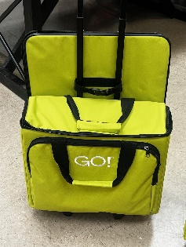 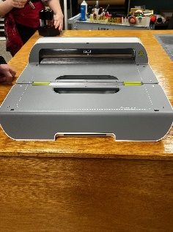 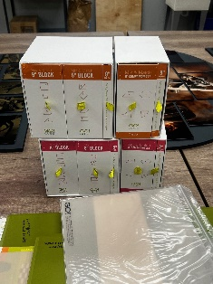 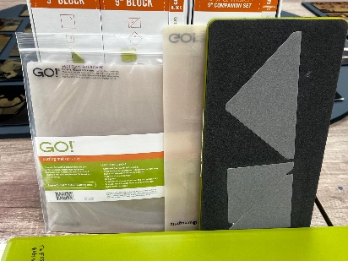

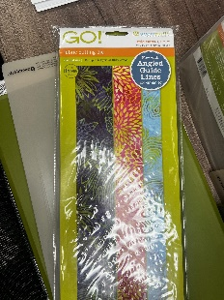 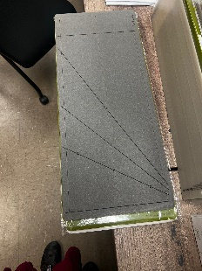 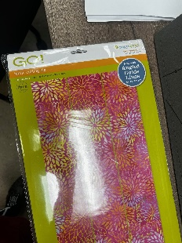

Call Arts & Crafts for questions at 623-856-6502

Bid forms available at Arts & Crafts or online at 56FSS.com

Mail or hand deliver sealed bids to 56 FSS/FSR, RE: Accuquilt 1 w/ Accessories,7383 N Litchfield Rd, Ste 3045, Luke AFB, AZ 85309

Deadline for accepting sealed bids: **22 November 2024 at 4:00 P.M.**

Bid opening will take place on: **11 November 2024 at 9:00A.M**.

Highest bidder will be notified within 24 hours. In case of tie for high bidder, we will attempt to contact each high bidder to submit another bid.

Payment by cash, credit card, or cashier’s check required no later than **26 November 2024**

All sales are final, and all equipment must be removed from premises by **1:00 P.M.,**

**27 November 2024**

Removal and transport of all items are the sole responsibility of the buyer.

56 FORCE SUPPORT SEALED BID SHEET

NAF EQUIPMENT AND VEHICLES

THE FOLLOWING BID IS OFFERED IN RESPONSE TO A SOLICITATION FOR SEALED BIDS DATED

LOT # 1

ITEM DESCRIPTION

**Accuquilt 1 w/ Accessories**

AMOUNT OF MY BID:

DATE OF BID:

PRINTED NAME

STREET ADDRESS

CITY, STATE, ZIP CODE

CONTACT INFORMATION:

TELEPHONE (PLEASE INCLUDE AREA CODE)

E-MAIL ADDRESS

I understand that all bids must be received by 56 FSS/FSR NO LATER than 4PM**,** 17 November 2024

***ALL SALES ARE FINAL***

***All equipment is offered in “AS IS” condition, no warranties or guarantees given***

***Each item will be sold to the highest bidder and payment must be made by cash, credit card, or cashier’s check before property is released***

***Removal and transport is sole responsibility of the buyer.***

_______________________________________________________________________

Signature of Bidder

ALL BIDS MUST BE PLACED IN AN ENVELOPE, SEALED, MARKED AS FOLLOWS, AND MAILED OR HAND-DELIVERED TO:

56 FSS/FSR

RE: NAF Property BID – Accuquilt 1 w/ Accessories

7383 N LITCHFIELD RD, SUITE 3045

LUKE AFB, AZ 85309